**CAPSTONE PROJECT – REACT APPLIACTION DEPLOYMENT**

1. **APPLICATION**
2. Configuring git in Ubuntu server

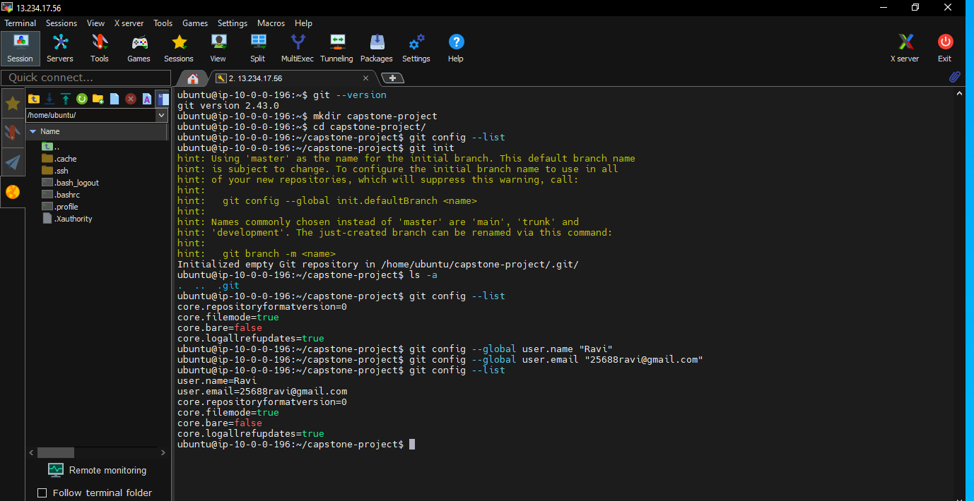

1. Copying the github repo URL <https://github.com/sriram-R-krishnan/devops-build>

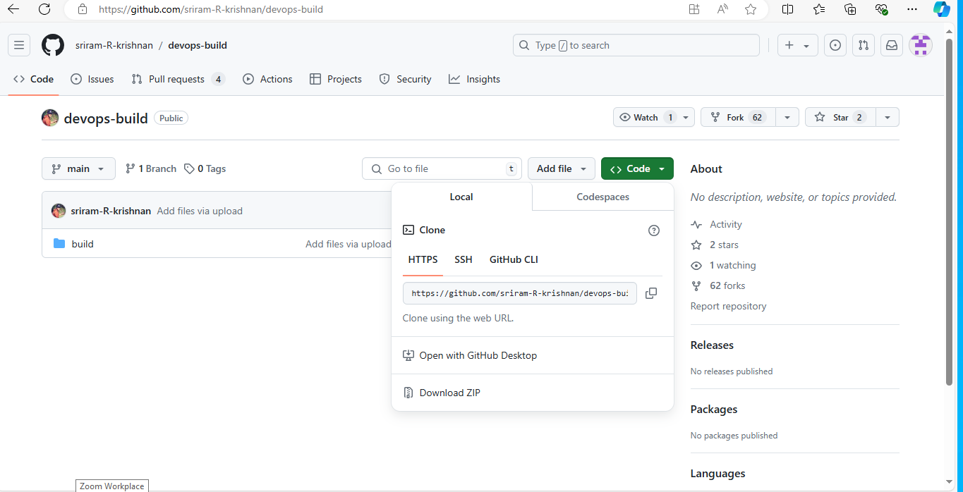

1. Cloning the github Repo URL

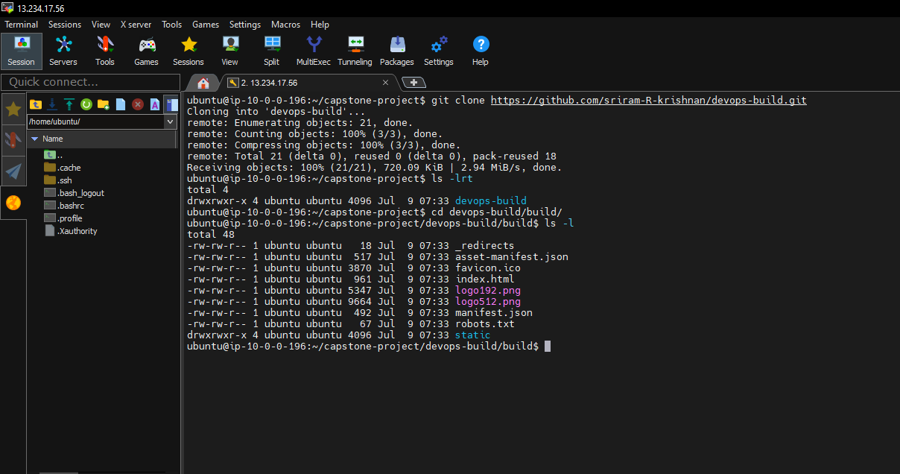

1. **Docker:**

1. Installing docker in Ubuntu server by docker official documentation

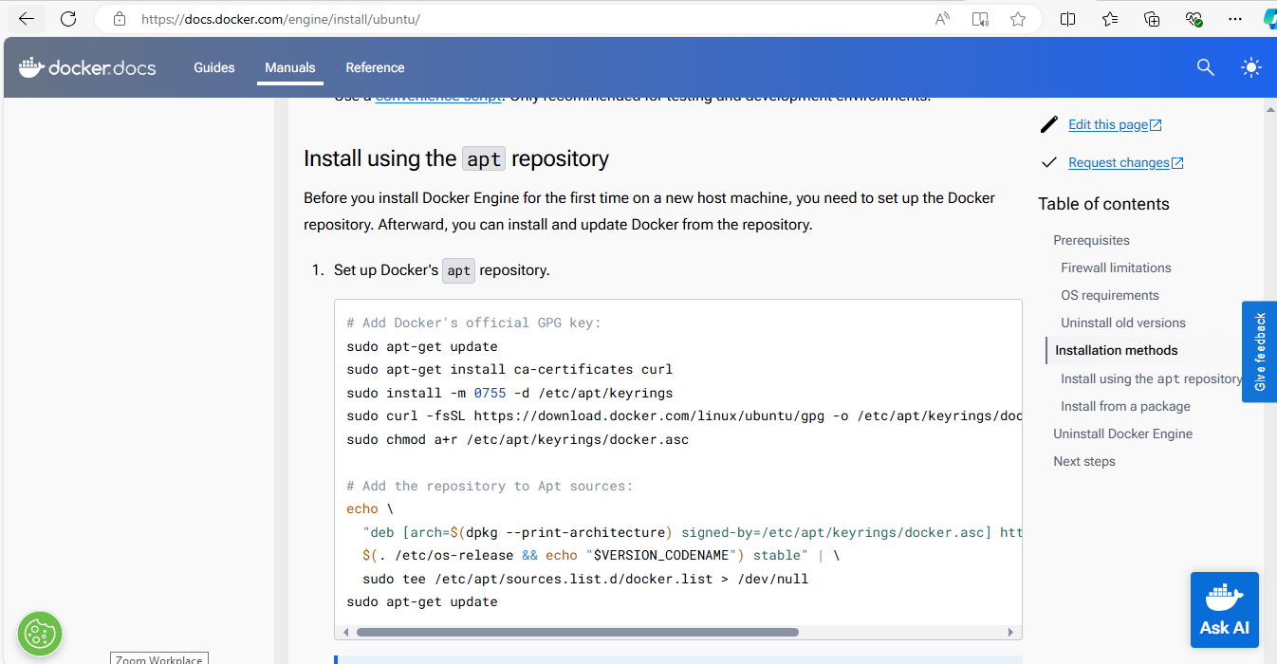

1. Docker and docker compose installation done successfully

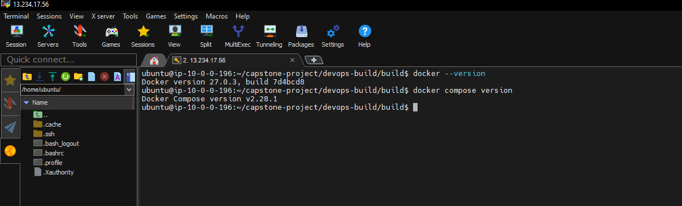

1. Creating a Dockerfile by the command vi Dockerfile

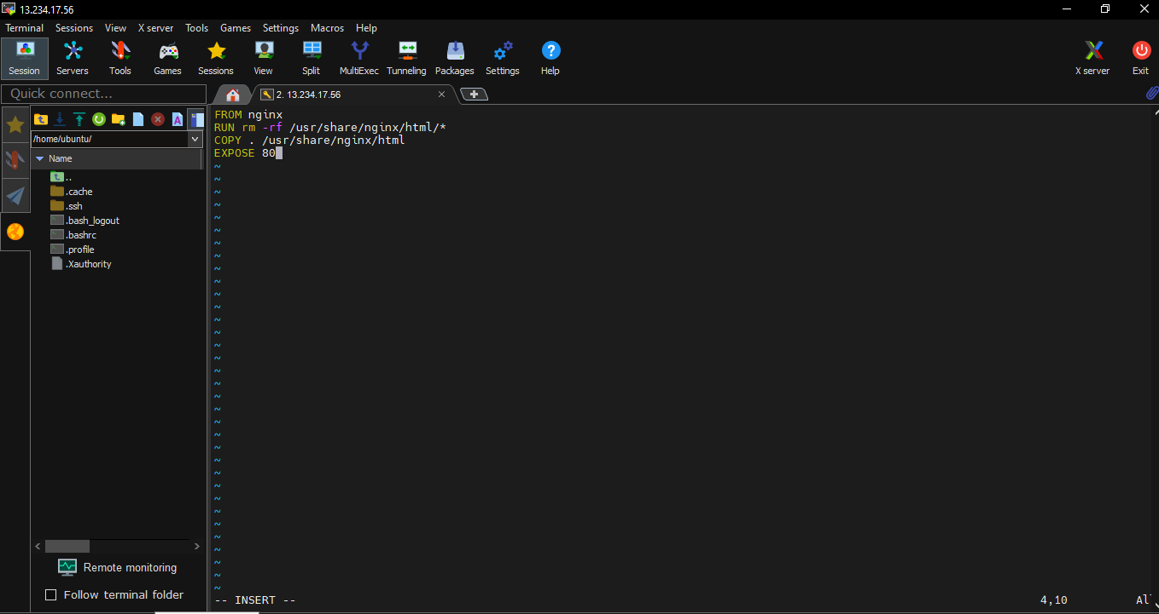

1. Building a docker image from the dockerfile by the command

docker build –t <imagname>:tagname

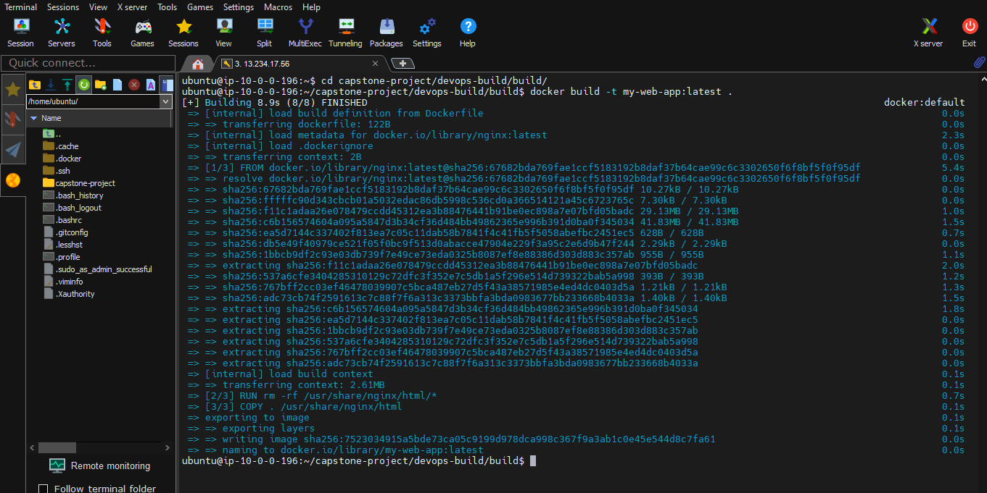

1. Docker image has been created

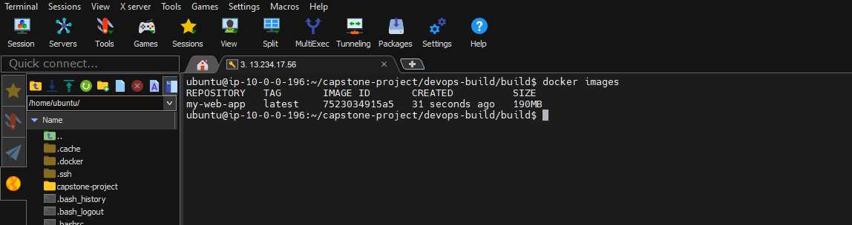

1. Creating a docker compose file by the command

vi docker-compose.yml

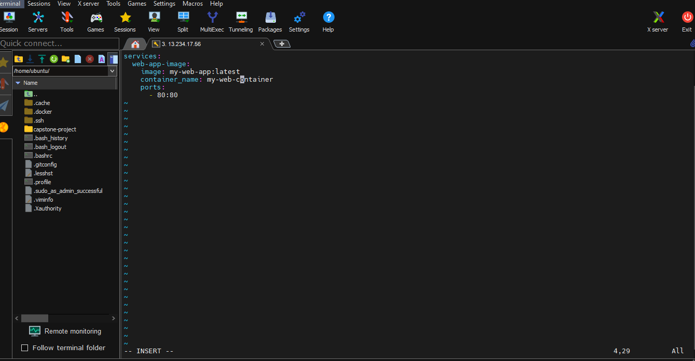

1. Running the docker compose file

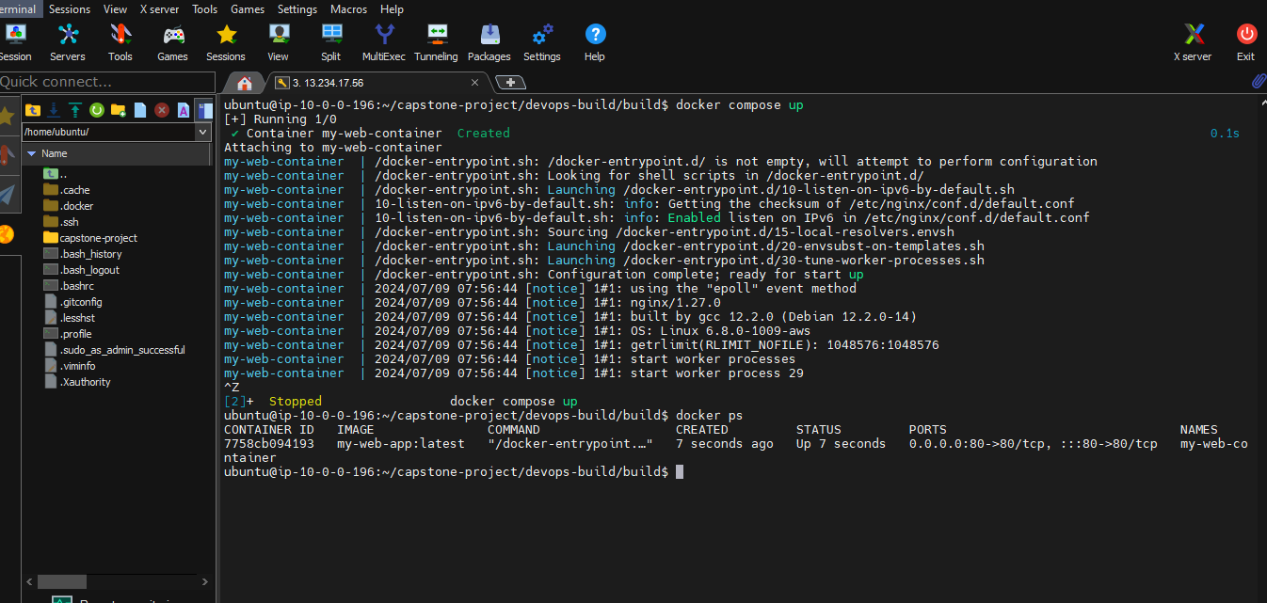

1. Successfully dockercompose is working and web URL page is opend

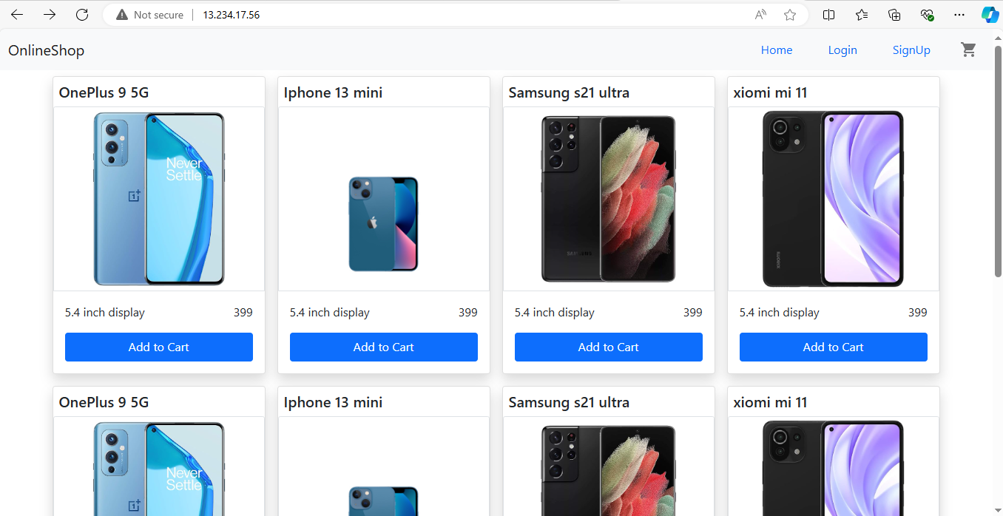

1. **Bash Scripting**

Writing 2 script files build.sh for building docker images and deploy.sh to deploy the dockerimage to server.

1. Writing build.sh script file

Starting by the command <vi build.sh>

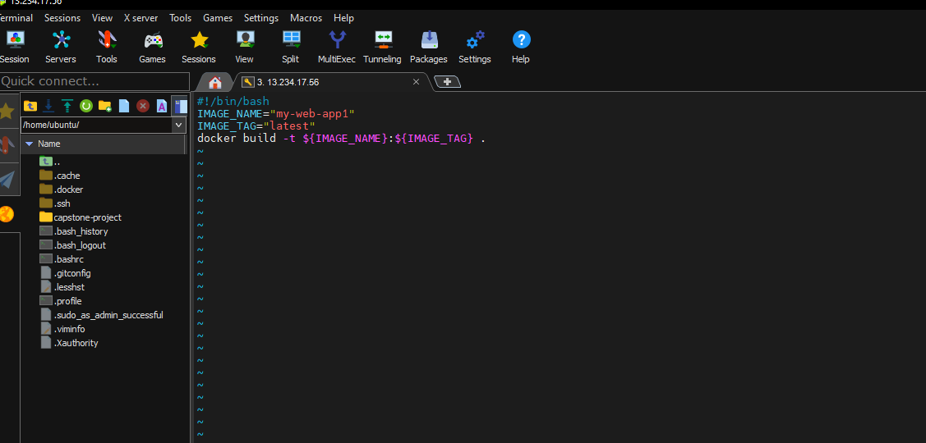

And changed the script file permission to execute the script file and executed script file and display by the command docker images

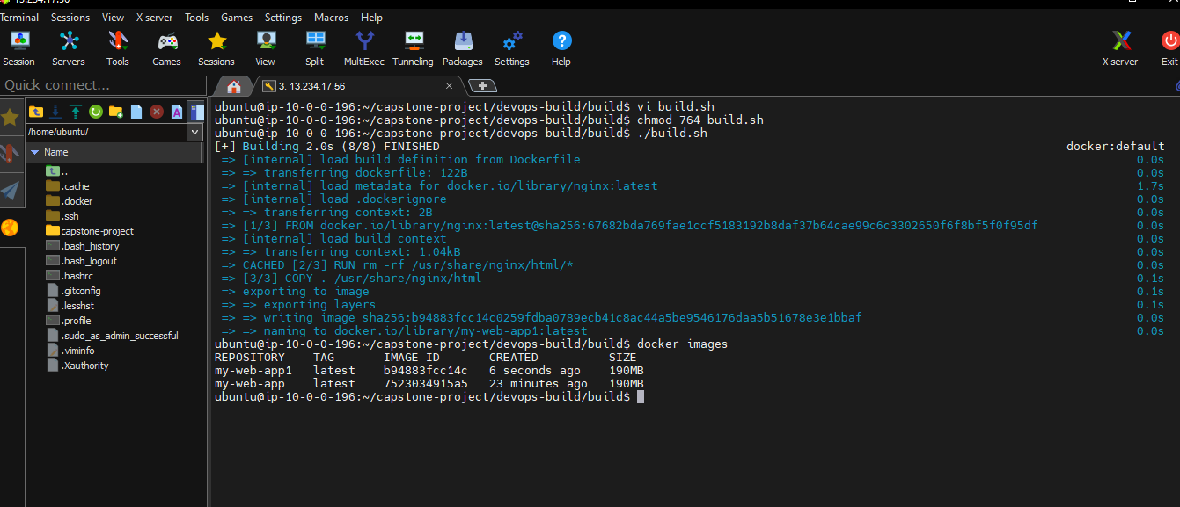

1. Writing the deploy.sh script by the command vi deploy.sh

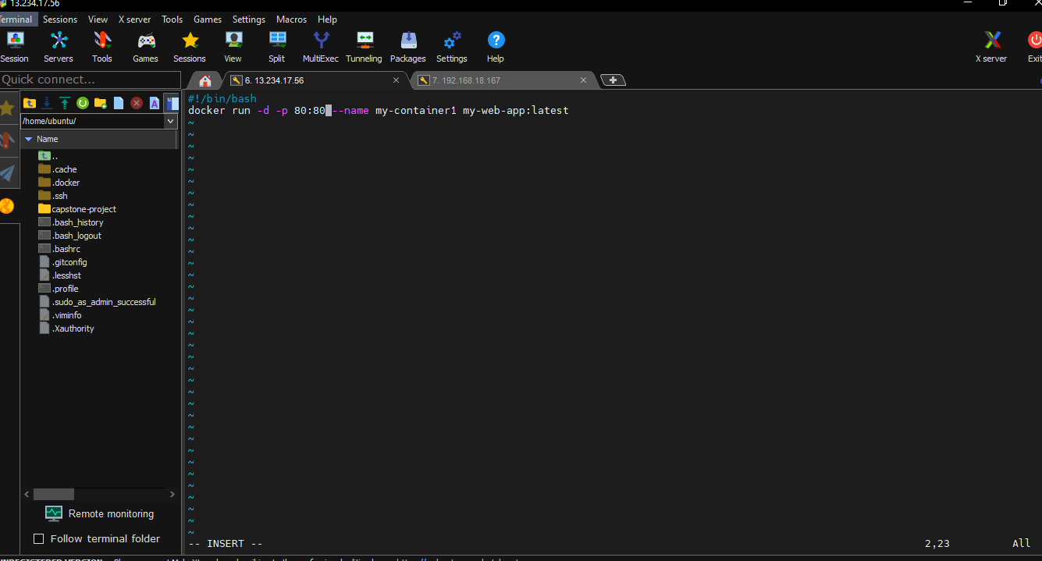

And changed the permission and deploy the script file written for deployment

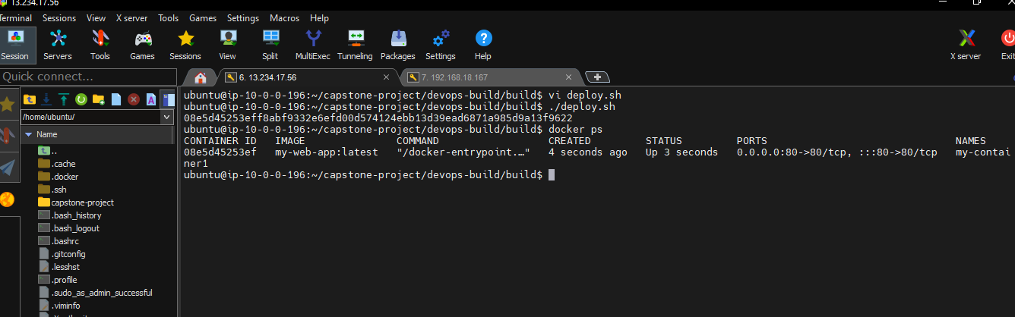

Result of deploy script and Deployed URL

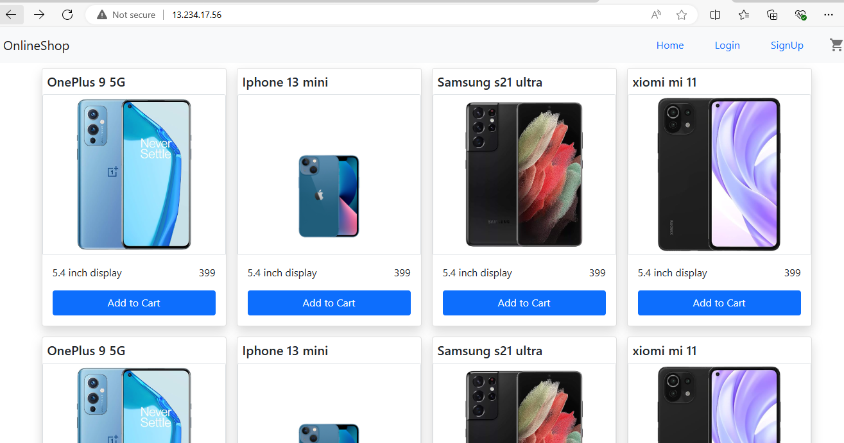

1. **Version Control:**

Push the code to github to dev branch and using gitignore file

1. Creating a Repository in git hub

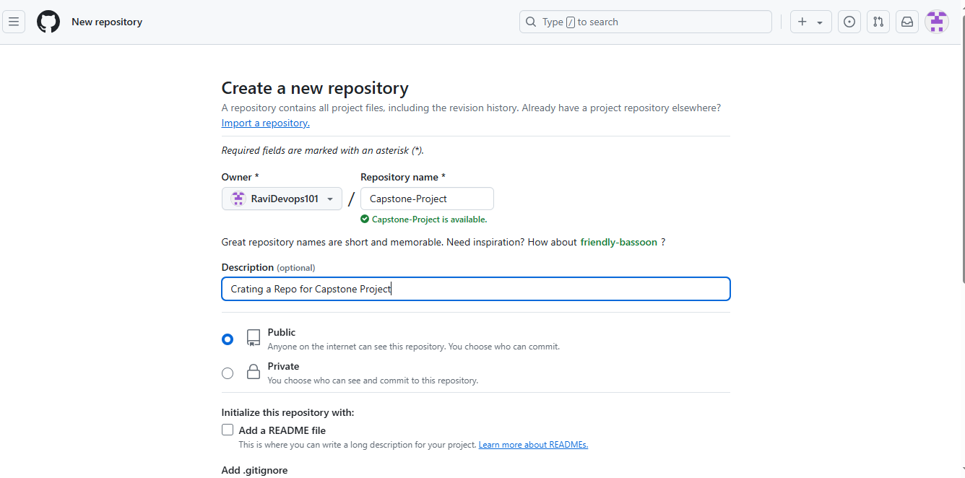

1. Repository Created

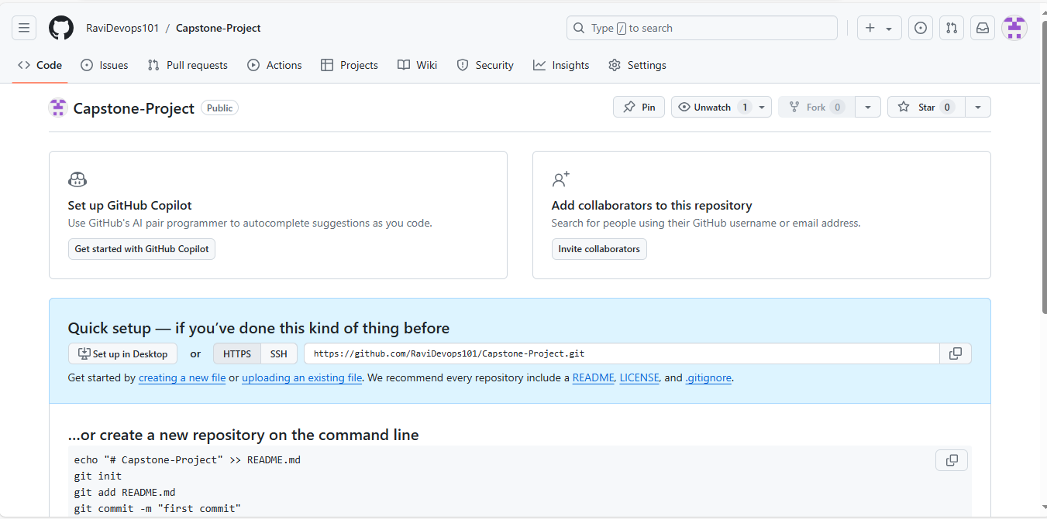

1. Creating a gitignore file by the command vi .gitignore

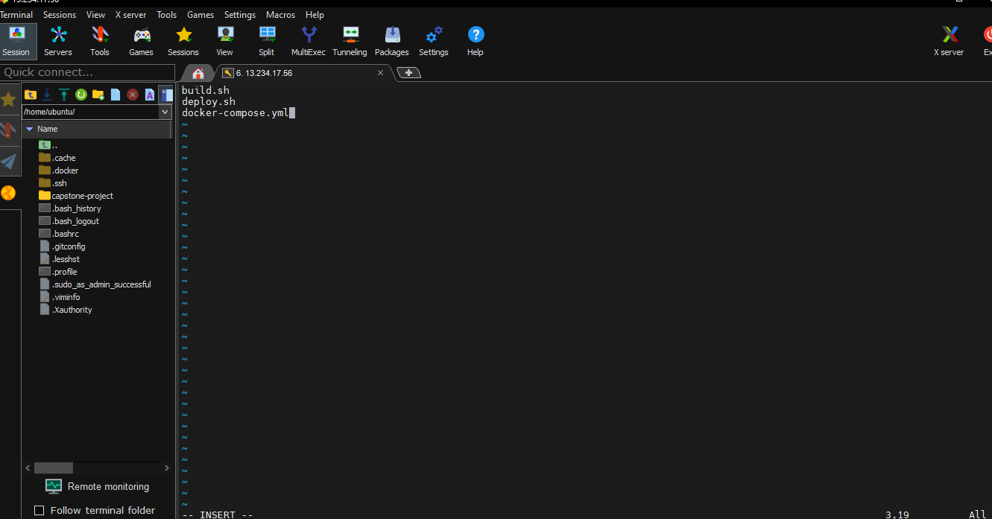

1. Creating a branch dev in git repository by command git checkout –b dev

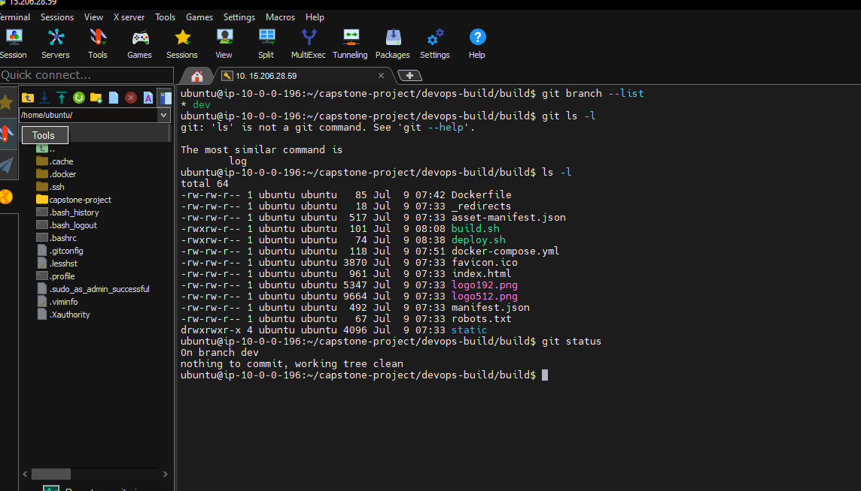

1. Pushuing the code to github URL

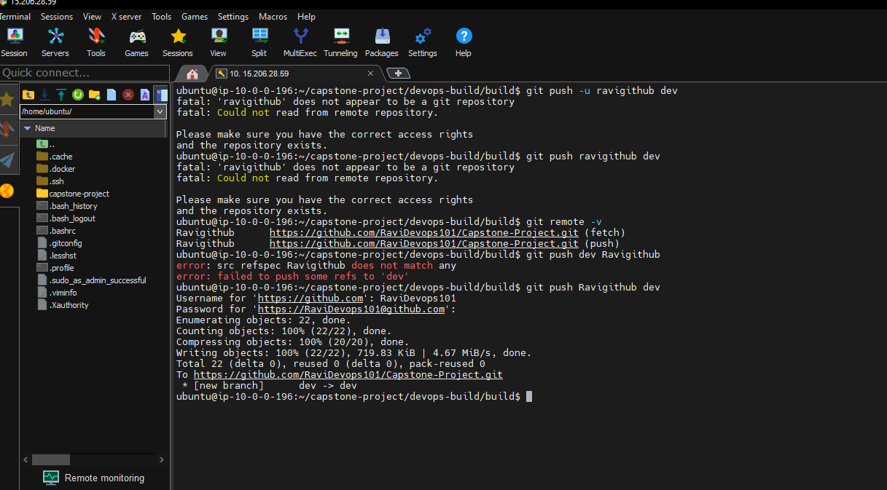

1. Finally code pushed to the github URL

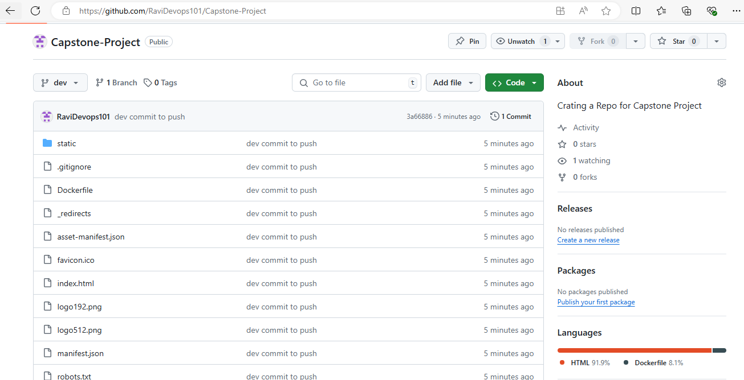

1. **Docker hub:**

Creating 2 Repos dev and prod in docherhub by pushing the images

1. Docker tagging the image by command docker tag for 2 repos dev and prod

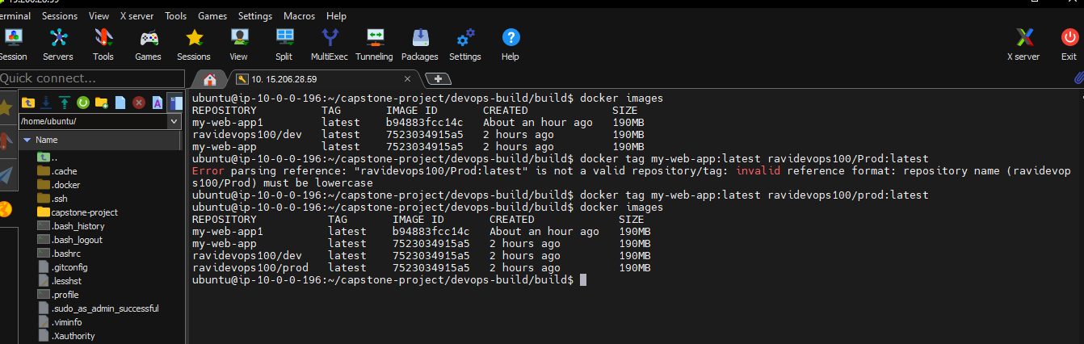

1. Using docker login command to add credentials in server

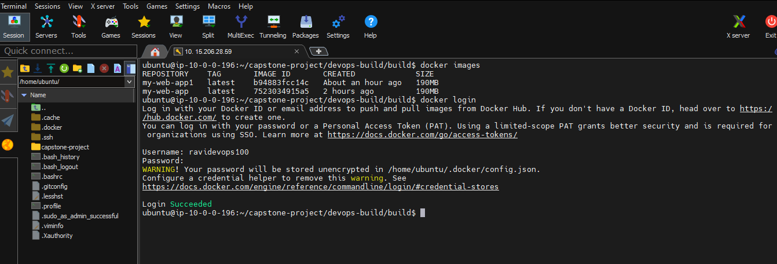

1. Pushed the tagged image to docker hub by docker push command

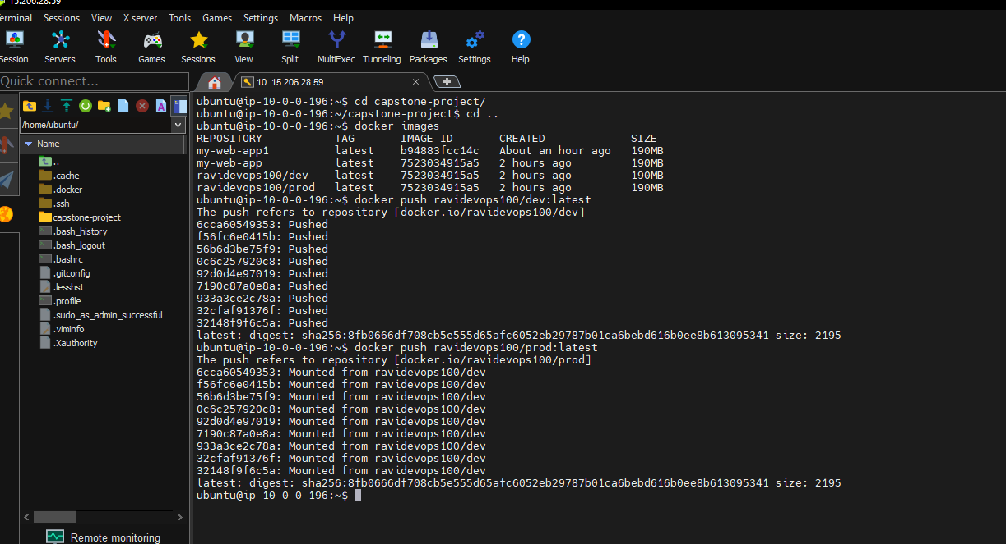

1. Docker images pushed to dockrhub successfully.

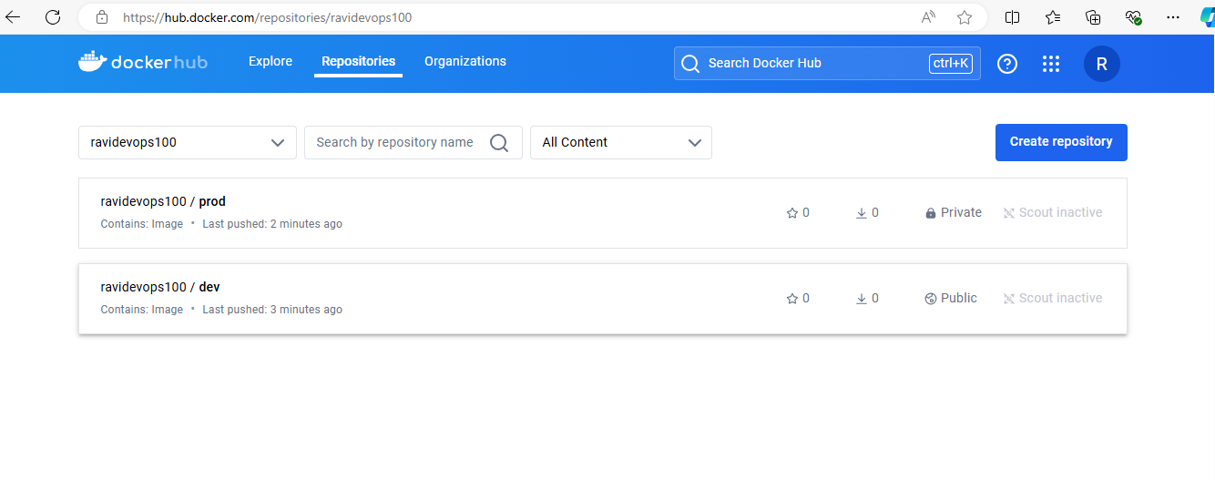

1. Made the prod repo into private